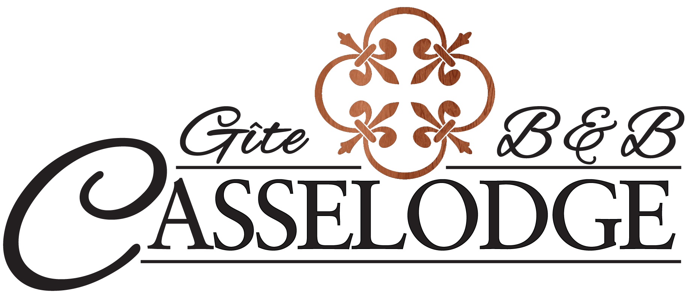
For your information – Casselodge policies

Casselodge is also our private home, and we ask that guests respectfully treat it as such. Below is additional information to assist you, along with some common house rules.

PLEASE NOTE: We reserve the right to terminate a reservation for guests who do not abide by our policies.

Barn Loft | Casselodge also offers a Barn Loft where you can be surrounded by our hobby farm animals. The barn loft is an apartment-style accommodation, which is fully furnished, and does not include ‘’breakfast’’. Guests who are afraid or allergic to animals should refrain from reserving the barn loft.
BBQ & eat-in facilities | A charcoal BBQ is located at the outdoor campfire. Access to a fridge and small bar area which includes microwave/convection oven, induction cooker, Tassimo Coffee Machine, kettle, and toaster is available on the lower level. There is an additional mini-fridge in the upstairs dining room. Guests can utilize any of the outdoor areas to have their picnic, and are asked to clean up and leave things as they found them. In case of inclement weather, guests may also use outside or lower level table (seats 4) for their meals.
Camp Fire | Campfires are allowed as long as the fire does not exceed the by-law requirement, which is 3 feet in height. A wood pile is provided at the camp fire, along with matches and blankets which are in the storage bin next to the campfire.
Check-in / Check-out times | Check-in is anytime between 4-8 pm (16:00 to 20:00) by appointment only. Please confirm your time of arrival so that we are there to greet you. Check-out is anytime prior to 11:00 am. Additional fees will apply if you would like to check-in earlier or check-out later.
Children | Children must be supervised at all times, especially around animals, in the hot tub, close to the river and pond areas, near farm equipment, near a campfire or any other area you feel may be a danger to your child.
Damages/Repairs | If you find something missing, damaged or not working, or if you lose, break, stain or spill something, please let us know. For severe damages or loss of items, a fee may apply.
Firearms | Visitors must adhere to the Firearms regulations.  Please visit the site: https://www.rcmp-grc.gc.ca/en/firearms/storing-transporting-and-displaying-firearms
Fireplace/  Fire extinguishers | We will be happy to prepare a cozy fire for your pleasure. Fire extinguishers are located in the kitchen and next to each indoor fireplace.
Footwear inside/outside the house | To maintain cleanliness, we ask that outdoor footwear not be worn inside the house. An assortment of clean slippers/flip flops is provided at the front entrance for your convenience. Please feel free to wear your own clean indoor footwear. Or, you can walk bare-feet or bare-socks in the house. Although it’s practical to walk onto the deck or outside of your room on the patio, we ask that you wear your outdoor footwear and refrain from wearing indoor sandals/flip-flops or walk with your socks/bare feet while outside.
Hot Tub | - Hot tub is available until 9pm (or later upon request) and is limited to guests inside the B&B.  - We will open/close the hot tub upon request.  - Shower with soap and water before entering hot tub and no soaps or oils in the hot tub.  - Enter/exit slowly.  - No jumping/diving.  - Only plastic glasses allowed in hot tub, no glass.  - Refrain from alcohol consumption, narcotics, or medication that could limit your capacities.  - Children under 12 must be accompanied by an adult at all times.  - Pregnant women, elderly persons or persons with heart disease, diabetes, high/low blood pressure or other serious illness should consult with physician prior to use.  - Do not sit/lay or lean on cover.  - Long hair must be tied up.
House Access | In addition to your own guest room, you are welcome to enter all of the common areas of our B&B. On the main floor, you can access the kitchen, dining room, living room, and powder room. On the lower level, you may access the main recreation room area through the hallway to the gym and shower. We ask that you respect everyone’s privacy by refraining from entering any other guest rooms or any area where a ‘private’’ sign appears (most likely on a closed door).
Ironing board / iron | Located in each upstairs bedroom, and off the recreation room on the lower level.
Keys | We keep the front door to Casselodge locked, as sometimes there are people who enter freely without ringing the bell. Each guest room is equipped with doors that lock and a key is provided to ensure security. If you leave the B&B, please be sure to bring your key with you. For guest rooms located on the lower level, you can access your room from outside after hours. A fee of $20 will apply to lost, stolen or damaged keys.
Noise | For those guest rooms in the older part of the house, the floor also serves as the ceiling for the room underneath it. Given the floors are made of wood and wooden floors may carry sound further, please use your best judgment with respect to noise level.
Payment & Cancellation | We accept cash, e-transfer and personal cheques. To guarantee your reservation, we require a deposit of $25.00. Should you decide to cancel at any time, the deposit is non-refundable, unless you reschedule at a later date. For severe damages, a fee will apply.
Relaxation and other activities | We pride ourselves on creating a relaxing environment for our guests. The following services/activities are available:  - Hot Tub  - Glider swing  - Various chairs, bistro tables, gazebos  - Take a walk on the path in our forest  - Canoe, 2 kayaks and life preservers, bicycles, snow shoes are all available upon request  - Indoor and outdoor games  - We are in close proximity to Larose Forest where you can enjoy long walks, snow shoeing, cross country skiing
Respect for the environment | Rooms are equipped with wastebaskets and recycling bins and we have an outdoor composter. We are on well water and ask our guests to minimize water waste. Each guest bathroom is equipped with a dual flush toilet that offers a full-flush option for solids and a partial-flush option for liquids therefore please flush as needed. Please refrain from throwing anything except toilet paper in the toilet. All other items should be discarded in the waste basket.
Respect for people | We are respectful of all people and we value diversity and as such, are respectful and courteous of all of our guests. We do not discriminate on the basis of race, color, age, national or ethnic origin, religion, sexual orientation, and marital or family status. We expect that our guests demonstrate tolerance as well as courteous and polite behavior. A zero tolerance policy applies in the event a guest demonstrates aggressive, disrespectful and abusive behavior and they will be asked to leave.
Room cleaning, towels and linen | - Clean linens and towels are provided for each new reservation.  - We will be happy to tidy your room or change linens upon request.  - Bath towels, face cloths and hand towels are available in your room. Please utilize the darker face cloths to remove make-up. Please refrain from utilizing the guest towels outside your guest room, except for hanging them to dry.  - Beach towels are available for hot tub and outdoor use.  - If you utilize additional pillows, please use pillowcases provided.
Smoking/Smoke Alarms/Carbon Monoxide Detectors | Smoking is not permitted inside the house nor in the Barn Loft, but you can certainly smoke outside, provided an ashtray is used to dispose of the cigarette butts. Our house is made entirely of wood and the barn shelters hay, and we ask our guests to smoke at least 20 feet from the buildings in order to avoid a fire. For your safety, the B&B is equipped with 8 smoke alarms strategically located throughout the house. Two carbon monoxide detectors are located on the main and lower levels of the house. The Barn Loft is equipped with 2 smoke detectors and one carbon monoxide detector.
Wi-fi / Telephone access / TV & entertainment | - Wi-fi is available and password is provided upon request.  - Telephone access for local calls, and calls within Canada.  - Satellite television and music CD’s are available in the living room.  - A television/DVD/VHS/movies are available in the lower level recreation area.  - Games, books, and magazines are available in the lower level recreation area.

Updated: November 13, 2021

